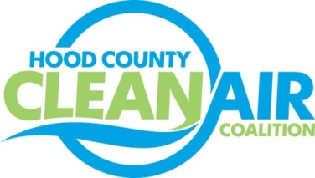
Meeting: Wednesday, August 31, 2016
Neely House
304 East Rucker Street, Granbury, Texas 76048
8:30-10:00 a.m.

Agenda

- Call Meeting to Order
- EPA Updates – Randy Pitre
- Regional Updates – Michelle McKenzie
  - Fleets for the Future
  - National Drive Electric Week
  - Air Quality Funding Opportunities for Vehicles
  - Air North Texas Progress Reports
- Local Updates – Michelle McKenzie
  - Review of May, June, July, and August 3rd Meeting Summaries
  - Review of Projects
    - Monthly Budget Review for April, May, June, and July
    - Status of Projects FY 16/17
    - Community Appreciation Day
  - August Ozone Update
  - 2016 Hood County Update for Ozone Advance
5.) Discussion
6.) Adjourn

